**Semester – End Examination Answer Key**

**SECTION – A**

**MULTIPLE CHOICE QUESTIONS (15 X 1= 15)**

1. c) Recommendation systems
2. b) Self-driving cars
3. b) Reinforcement Learning
4. a) To break down a complex problem into simpler subproblems
5. a) DFS explores deeper into the search space, while BFS explores broader
6. a) First Order Logic
7. a) Frames provide a clear, structured representation
8. c. A large collection of text data
9. b. To process sentences without predefined grammars
10. b. It improves the accuracy of identifying grammatical structures
11. a. S → NP VP, NP → Det N, VP → V
12. c. Showcasing Expert Systems' capabilities in complex domains
13. b. It makes decisions based on rules and knowledge
14. a. build the rule base for identifying tax exemptions
15. c. rules

**SECTION – B**

**ANSWER ANY THREE QUESTIONS (3 X 10= 30)**

**16. Define artificial intelligence and give two real-life examples of its application.**

**Answer:**

AI is the branch of computer science which deals with helping machines find solutions to complex problems in a more human-like fashion. AI is techniques that help machines mimic human behaviour. AI is the branch of computer science with which we can create intelligent machine which can think like human, able to take decision and behave like human.

Real Life Examples:

* Gmail's spam filter
* Smart assistant like Alexa, Siri
* Recommendation Systems like Netflix, Spotify
* Smartphone Features like face recognition, autocorrect, voice to text
* Navigation and Traffic Prediction
* Social Media
* Online Shopping
* Photo Organization
* Smart Home Devices

**17. Explain AI knowledge cycle.**

Answer:

An Artificial intelligence system has the following components for displaying intelligent behavior:

* Perception
* Learning
* Knowledge Representation and Reasoning
* Planning
* Execution

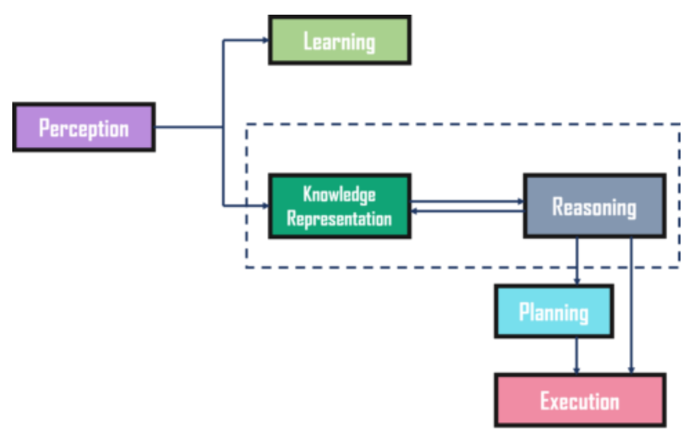

**18. Explain Translation in NLP along with its approaches. Give its significance.**

**Answer:**

Machine translation is a sub-field of computational linguistics that focuses on developing systems capable of automatically translating text or speech from one language to another. In Natural Language Processing (NLP), the goal of machine translation is to produce translations that are not only grammatically correct but also convey the meaning of the original content accurately.

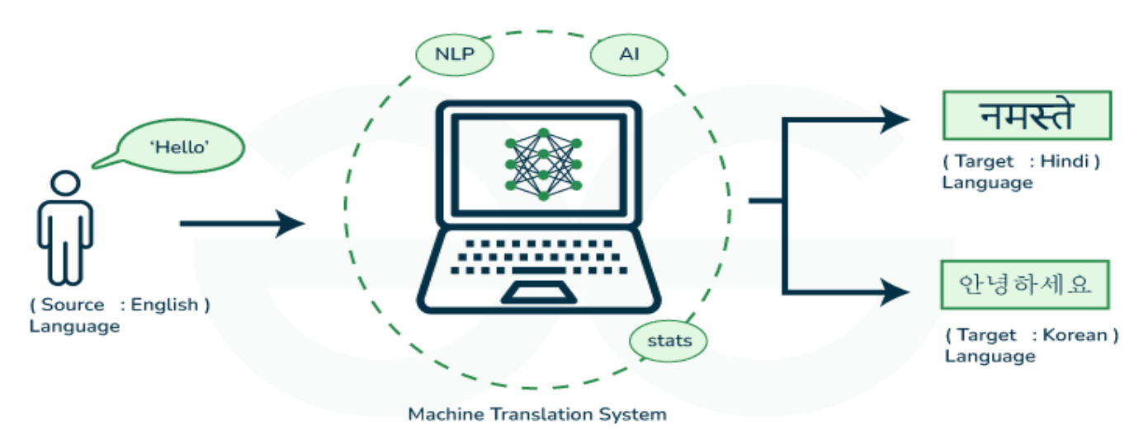

Approaches:

1. Rule-Based Machine Translation

Rule-based machine translation relies on these resources to ensure precise translation of specific content. The process involves the software parsing input text, generating a transitional representation, and then converting it into the target language with reference to grammar rules and dictionaries.

1. Statistical Machine Translation

* Rather than depending on linguistic rules, statistical machine translation utilizes machine learning for text translation. Machine learning algorithms examine extensive human translations, identifying statistical patterns.
* When tasked with translating a new source text, the software intelligently guesses based on the statistical likelihood of specific words or phrases being associated with others in the target language.

1. Neural Machine Translation (NMT)

* A neural network, inspired by the human brain, is a network of interconnected nodes functioning as an information system. Input data passes through these nodes to produce an output.
* Neural machine translation software utilizes neural networks to process vast datasets, with each node contributing a specific change from source text to target text until the final result is obtained at the output node.

1. Hybrid Machine Translation

* Hybrid machine translation tools integrate multiple machine translation models within a single software application, leveraging a combination of approaches to enhance the overall effectiveness of a singular translation model.
* This process typically involves the incorporation of rule-based and statistical machine translation subsystems, with the ultimate translation output being a synthesis of the results generated by each subsystem.

**19. Analyze the design and impact of MYCIN and R1 expert systems. What limitations did they face?**

**Answer:**

MYCIN

* Systems like MYCIN assist doctors in diagnosing infections by suggesting treatments based on symptoms. The form –mycin comes from a combination of two elements. The first is Greek mýkos, meaning “fungus.” The second is the suffix -in, a variant of –ine, which is used to name chemical terms. The form – mycin literally refers to chemicals from fungus (or fungus-like bacteria).
* It is a software program.
* Primarily designed to diagnose bacterial infections and recommend antibiotics.

Design of MYCIN:

* MYCIN was developed at Stanford University to diagnose bacterial infections and recommend antibiotics.
* It utilized a rule-based system where knowledge about infections and treatment was encoded in the form of production rules ( if-then).
* MYCIN employed a backward chaining reasoning approach, starting with the conclusion (diagnosis) and working backward to gather the necessary evidence (symptoms, patient history).

Impact of MYCIN:

Influence on Expert Systems:

MYCIN demonstrated the effectiveness of rule-based systems in complex decision-making domains and paved the way for future medical expert systems.

Understanding of Medical Knowledge:

It provided insights into the nature of medical reasoning and knowledge representation, influencing the design of subsequent systems in healthcare.

Limitations of Traditional Diagnosis:

MYCIN highlighted the limitations of traditional medical training and decision-making, showing how expert systems could complement human expertise.

R1

* R1- Used to configure orders of computer systems.
* It is also known as XCON – eXpert CONfigurer.
* It is an Expert System.
* Used to configure orders of computer systems.
* When a company wanted to buy a computer system, they would specify what they needed, like the type of processor, amount of memory, storage capacity, and other features.
* The order involves selecting the right combination of parts to build a computer system that meets the customer's needs. This can be complicated.
* XCON takes the details from the customer’s order and automatically figures out which parts to use.
* It checks that everything is compatible and suggests the best configuration.

**20. Explain Propositional logic. Construct a truth table for the following compound proposition**

**a) ¬ (p ∧ q) ∨ (p → r) b) (p ∧ q) ∨ ¬r**

**Answer:**

Propositional logic (PL) is the simplest form of logic where all the statements are made by propositions. A proposition is a declarative statement which is either true or false. It is a technique of knowledge representation in logical and mathematical form.

Example:

1. Normal human body temperature is 98.6F.
2. The Sun rises from West (False proposition)
3. 3+3= 7(False proposition)
4. 5 is a prime number.

a) ¬ (p ∧ q) ∨ (p → r)

Answer:

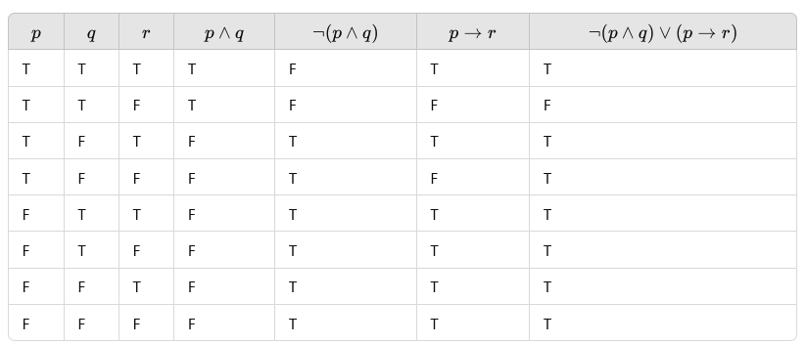

b) (p ∧ q) ∨ ¬r

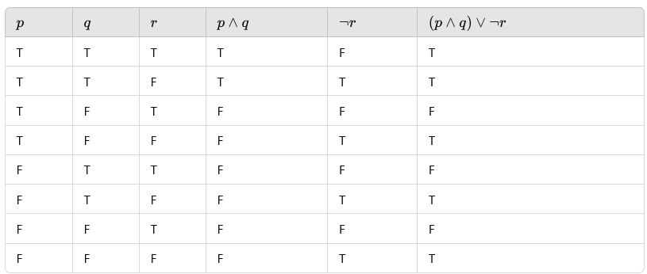

**ANSWER ANY TWO QUESTIONS (2 X 15= 30)**

**21. Define hill climbing in the context of heuristic search. What are its types?**

### ****Answer:****

### **Definition of Hill Climbing in Heuristic Search**

Hill climbing is a heuristic search algorithm used in optimization and artificial intelligence to find a solution that maximizes (or minimizes) a certain objective function. It iteratively moves towards the direction of increasing (or decreasing) value, starting from an arbitrary point in the search space, with the aim of reaching a local or global optimum.

In the context of heuristic search:

* The algorithm evaluates neighboring states of the current state and moves to the neighbor with the best objective value.
* It uses no backtracking, making it efficient but prone to getting stuck in local optima.

### **Types of Hill Climbing**

1. **Simple Hill Climbing**
   * **Definition:** A greedy approach where the algorithm evaluates neighbors of the current state one at a time and moves to the first neighbor with a better objective value.
   * **Advantages:** Simple and fast.
   * **Disadvantages:** Can easily get stuck in local maxima, plateaus, or ridges.
2. **Steepest-Ascent Hill Climbing**
   * **Definition:** Also called "gradient ascent," this type evaluates all the neighbors of the current state and moves to the neighbor with the highest improvement in the objective function.
   * **Advantages:** More thorough exploration of neighbors, reducing the risk of missing better solutions.
   * **Disadvantages:** Computationally expensive, especially for large search spaces.
3. **Stochastic Hill Climbing**
   * **Definition:** Instead of systematically evaluating neighbors, this type randomly selects one neighbor and decides whether to move based on its value compared to the current state.
   * **Advantages:** Adds randomness, reducing the chance of getting stuck in local maxima.
   * **Disadvantages:** Can take longer to converge to an optimum.
4. **Random-Restart Hill Climbing**
   * **Definition:** Repeatedly applies hill climbing starting from different random initial states. If one search gets stuck in a local optimum, the algorithm restarts the search from a new point.
   * **Advantages:** Helps escape local maxima and increases the chance of finding the global optimum.
   * **Disadvantages:** May require many restarts, increasing runtime.

**22.**

**Answer**

**a. Explain the concept of parsing in NLP. Briefly explain the differences between top-down and bottom-up parsing strategies.**

* Parsing is a crucial technique in Natural Language Processing (NLP) that involves analyzing a string of symbols, either in natural language or computer languages, according to the rules of a formal grammar.
* Parsing helps in understanding the syntactic structure of a sentence and is essential for various NLP tasks such as machine translation, question answering, and text-to-speech systems.

Parsing Techniques in NLP

1. Top-Down Parsing

Top-down parsing is a method of parsing where the process starts from the root of the parse tree (usually the start symbol of a grammar) and tries to break down the sentence into smaller components (like words and phrases), following the grammar rules. The parser predicts what structure the sentence might have and tries to match it with the actual input.

Example

S → NP VP (A sentence is made of a noun phrase and a verb phrase)

NP → Det N (A noun phrase is a determiner followed by a noun) V

P → V NP (A verb phrase is a verb followed by a noun phrase)

Det → 'the‘

N → 'cat' | 'mouse‘

V → 'chases‘

And the sentence to parse: "the cat chases the mouse".

Step-by-Step Top-Down Parsing

1. Start with the start symbol (S):

The sentence structure is predicted as S → NP VP.

2. Expand NP (Noun Phrase):

* NP → Det N.
* Now, predict that the first word in the sentence will be a Det (determiner) followed by a N (noun).

3. Match with input:

* The input starts with "the", which matches the rule Det → 'the'.
* Now, look for a noun. The next word in the input is "cat", which matches N → 'cat'.

4. Expand VP (Verb Phrase):

* VP → V NP.
* The verb phrase is predicted as a verb followed by a noun phrase.

5. Match with input:

* The next word in the input is "chases", which matches V → 'chases'.
* Now, look for another noun phrase (NP).

6. Expand NP:

* NP → Det N again.
* The next word is "the", matching Det → 'the', and the last word is "mouse", matching N → 'mouse'.

7. Complete the parse:

The whole input "the cat chases the mouse" is successfully parsed according to the grammar.

2. Bottom-Up Parsing

Bottom-Up Parsing is a parsing technique in which the parser starts from the input (the individual words or tokens of a sentence) and tries to build the parse tree by working its way upwards, combining smaller parts (like words or phrases) into larger structures until it reaches the start symbol of the grammar.

How Bottom-up Parsing Works:

* The parser begins with the input words and repeatedly tries to find grammar rules that can combine them into bigger phrases.
* Reduces small parts (like words) into larger parts (like noun phrases or verb phrases) based on grammar rules.
* Continues this process until the whole sentence is reduced to the start symbol of the grammar (e.g., a "sentence").

Example:

Consider the sentence: "The dog barks.“

Grammar Rules:

* S → NP VP (A sentence is made of a noun phrase followed by a verb phrase)
* NP → Det N (A noun phrase is made of a determiner and a noun)
* VP → V (A verb phrase is just a verb)
* Det → 'The'
* N → 'dog'
* V → 'barks'

1. Input: "The dog barks.“

2. Look at the words: Identify parts of speech (Det = "The", N = "dog", V = "barks").

Det: "The“

N: "dog“

V: "barks"

3. Apply the rules bottom-up:

* First, combine Det + N → NP:

"The" + "dog" → NP ("The dog")

* Now combine V → VP:

"barks" → VP

4. Final reduction:

Combine NP + VP → S (Sentence):

"The dog" + "barks" → S (The dog barks)

The parser successfully constructs a valid parse tree for the sentence, starting from the individual words and working its way up to form the full sentence.

**b. Explain the concept of Grammar in NLP.**

### **Concept of Grammar in NLP**

In Natural Language Processing (NLP), **grammar** refers to the set of rules that define the structure of sentences in a language. It specifies how words and phrases are organized to convey meaning. NLP uses grammar to analyze, interpret, and generate human language effectively.

1. **Syntax Rules**: Grammar focuses on syntax, ensuring sentences are well-formed and follow the correct structure (e.g., Subject-Verb-Object order in English).
2. **Parsing**: Grammar is used for parsing, which breaks down sentences into their components (e.g., noun phrases, verb phrases) for understanding and processing.
3. **Types of Grammars**:
   * **Context-Free Grammar (CFG)**: Defines rules for forming syntactically valid sentences.
   * **Dependency Grammar**: Represents relationships between words in a sentence.
4. **Applications**: Grammar is crucial in tasks like machine translation, text summarization, and sentiment analysis.
5. **Challenges**: Handling ambiguity and diverse grammatical constructs across languages.

**23. Evaluate the impact of reinforcement learning in AI. Provide real-world examples of its applications.**

**Answer:**

### **Impact of Reinforcement Learning in AI**

Reinforcement Learning (RL) has significantly impacted AI by enabling systems to learn optimal behavior through interaction with their environment, guided by rewards and penalties. Unlike supervised learning, RL does not rely on labeled data but learns from trial and error, making it ideal for dynamic and complex tasks.

#### **Key Impacts**

1. **Autonomous Decision-Making**: RL empowers AI systems to make decisions in uncertain and changing environments.
2. **Optimization in Dynamic Systems**: RL excels in optimizing sequential decisions where future outcomes depend on current actions.
3. **Scalability**: RL can handle large and complex problems with minimal prior knowledge, as seen in game playing and robotics.

#### **Real-World Applications**

1. **Game Playing**: RL has achieved superhuman performance in games like:
   * **AlphaGo**: Used RL to beat human champions in the game of Go.
   * **DeepMind’s DQN**: Mastered Atari games directly from raw pixels.
2. **Robotics**:
   * RL is used in robot training for tasks like navigation, grasping objects, and performing complex movements in real-world environments.
   * Example: Boston Dynamics uses RL to enhance robot agility and balance.
3. **Autonomous Vehicles**:
   * RL algorithms enable self-driving cars to make decisions, such as lane changing, obstacle avoidance, and traffic management.
4. **Healthcare**:
   * RL optimizes treatment strategies for diseases like cancer by personalizing therapy schedules based on patient responses.
   * Example: Drug discovery processes benefit from RL by finding effective drug combinations.
5. **Energy Management**:
   * Google DeepMind’s RL system reduced energy consumption in data centers by 40%.
6. **Finance**:
   * RL is used for portfolio optimization, stock trading strategies, and fraud detection.

**24. Write Python code, apply and explain the steps of Depth First Search algorithm for the following graph.**

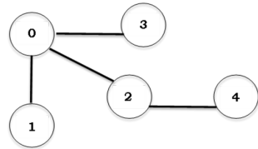

**Answer:**

def dfs(graph, start):

stack = []

visited = set()

stack.append(start)

while stack:

node = stack.pop()

if node not in visited:

print(node, end=' ')

visited.add(node)

for neighbor in reversed(graph[node]):

if neighbor not in visited:

stack.append(neighbor) graph = {

0: [1, 3, 2],

1: [],

2: [4],

3: [],

4: []

}

Output:

DFS Traversal of the Graph: 0 1 3 2 4

### ****Steps of DFS Traversal for the Given Graph****

Starting from node 0:

1. Visit 0 → **Mark as visited**.
2. Move to neighbor 1 → Visit 1 → Backtrack to 0.
3. Move to neighbor 3 → Visit 3 → Backtrack to 0.
4. Move to neighbor 2 → Visit 2.
5. Move to neighbor 4 (from 2) → Visit 4 → Backtrack.